6. ANALYSIS RESULTS

6.1 GENERAL
This chapter furnishes typical deflection curves, bending moment diagrams, shear force diagrams and axial force diagrams under the gravity, wind and earthquake loading. Validation of SAP gravity analysis is also presented by comparing the results from SAP by those obtained by Substitute Frame method.

6.2 VERIFICATION OF SAP2000 GRAVITY ANALYIS
6.2.1 Frame Information
Frame joining columns C5, C6, C’6 and C’5 by beams B8, B9 and B’8 at Y = -6.1 is analysed by Substitute Frame method. Fig. 6.1 shows the frame section (also shown in section 4.7.3).

Gravity loads are taken as 1.5 (DL + LL) in form of equivalent UDL on beams corresponding to triangular and trapezoidal distribution.
Beam Section = 200 mm × 400 mm
Column Section = 300 mm × 500 mm
Moment of Inertia of beam section = 1.067 × 10⁻³ m⁴
Moment of Inertia of column section = 3.125 × 10⁻³ m⁴
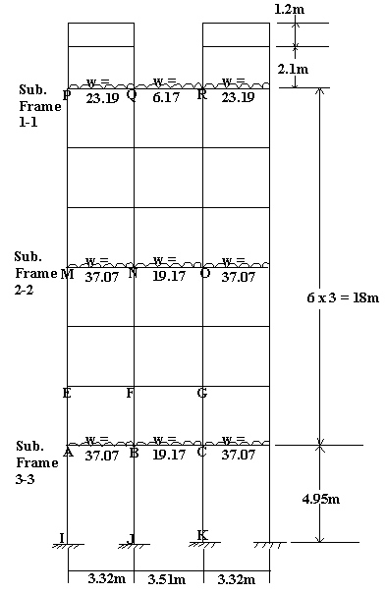
Fig. 6.1 Frame section in XZ plane at Y = -6.1

Due to symmetry of the frame and the loading, there would be no sway and hence Substitute Frame method of analysis is applicable. One possible substitute frame for this frame could be:
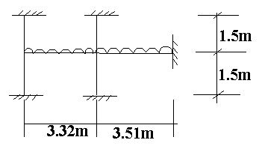
Fig. 6.2 Substitute Frame
According to the Moment Distribution method, fixed end moments when released get transferred to the connecting frame members in inverse proportion of their flexural stiffness given by EI / L. Since all the elements are of concrete only, E is redundant in this case. So, the distribution factor (DF), fraction by which moment released will transfer to frame element under consideration, is given by
DF_{ij} = $\frac{(\frac{I}{L}){\text{for}}_{{\text{frame}}_{}}}{\sum_{{\text{all}}_{{\text{frames}}_{{\text{from}}_{i}}}}{(\frac{I}{L})}}$
where summation is over all connected frame elements in the plane of moment released.
For example, in ground floor substitute frame
DF_{AE} = 0.52 DF_{BA} = 0.14
DF_{AI} = 0.32 DF_{BF} = 0.45
DF_{AB} = 0.16 DF_{BJ} = 0.27
DF_{BC} = 0.13
A fixed end moment for UDL, w is calculated as M_{fix} = $\frac{{\text{wl}}^{2}}{\text{12}}$
Similarly, fixed end moments are calculated for each loaded frame and DFs are evaluated.

6.2.2 Substitute Frame analysis
Tables 6.1(a), (b) and (c) show the moment distribution analysis for substitute frame
1-1, 2-2 and 3-3 as defined in the Fig. 6.1. Only relevant values which are used for the comparison purpose are shown.

6.2.2.1 Substitute Frame 1-1
Table 6.1 (a) Substitute Frame analysis for substitute frame 1-1
P |  |  | Q |  |  |  | R
P- | P- | PQ | QP | Q- | Q- | QR | RQ | R-
0.52 | 0.37 | 0.11 | 0.10 | 0.47 | 0.33 | 0.10 | 0.11 | 0.37
 |  | -21.13 | 21.13 |  |  | -6.33 | 6.33
 |  | 4.14 | -1.50 |  |  | -1.50
 |  | -0.75 | 1.07 |  |  | 0.75
 |  | 0.08 | -0.18 |  |  | -0.18
 |  | -0.09 | 0.04 |  |  | 0.09
 |  | 0.01 | -0.01 |  |  | -0.01
 |  | -19.17 | 20.72 |  |  | -7.16

6.2.2.2 Substitute Frame 2-2
Table 6.1 (b) Substitute Frame analysis for substitute frame 2-2
M |  |  | N |  |  |  | O
M- | M- | MN | NM | N- | N- | NO | ON | O-
0.43 | 0.43 | 0.13 | 0.12 | 0.38 | 0.38 | 0.11 | 0.13 | 0.43
 |  | -34.05 | 34.05 |  |  | -19.67 | 19.67
13.85 | 13.85 | 4.43 | -1.77 | -5.60 | -5.60 | -1.50 | -1.58
 |  | -0.87 | 2.22 |  |  | 0.81
0.38 | 0.38 | 0.11 | -0.33 | -1.11 | -1.11 | -0.31
 |  | -0.18 | 0.06 |  |  | 0.16
0.08 | 0.08 | 0.02 | -0.03 | -0.08 | -0.08 | -0.02
 |  | -30.54 | 34.24 |  |  | -20.59

6.2.2.3 Substitute Frame 3-3
Table 6.1 (c) Substitute Frame analysis for substitute frame 3-3
A |  |  | B |  |  |  | C
AE | AI | AB | BA | BF | BJ | BC | CB | CG
0.52 | 0.32 | 0.16 | 0.14 | 0.45 | 0.27 | 0.13 | 0.13 | 0.45
 |  | -34.05 | 34.05 |  |  | -19.67 | 19.67
 |  | 5.44 | -2.01 |  |  | -1.87
 |  | -1.00 | 2.73 |  |  | 0.97
 |  | 0.16 | -0.51 |  |  | -0.48
 |  | -0.25 | 0.08 |  |  | 0.23
 |  | 0.04 | -0.04 |  |  | -0.04
 |  | -29.68 | 34.32 |  |  | -20.84

A comparison of maximum positive and negative bending moments obtained from above analysis and SAP is presented in Table 6.2.

Table 6.2 Comparison of results
Floor | B8 |  |  |  | B9
Floor | Sub. Frame Anal. |  | SAP2000 |  | Sub. Frame Anal. |  | SAP2000
 | +M₃₃ | -M₃₃ | +M₃₃ | -M₃₃ | +M₃₃ | -M₃₃ | +M₃₃ | -M₃₃
0 | 19.1 | 34.3 | 10.9 | 28.3 | 8.7 | 20.8 | 6.8 | 20.0
1 | 18.7 | 34.2 | 11.1 | 32.3 | 8.9 | 20.6 | 7.3 | 19.3
2 | 18.7 | 34.2 | 10.6 | 33.5 | 8.9 | 20.6 | 7.0 | 19.5
3 | 18.7 | 34.2 | 10.6 | 34.9 | 8.9 | 20.6 | 7.1 | 19.8
4 | 18.7 | 34.2 | 10.6 | 35.8 | 8.9 | 20.6 | 7.4 | 20.2
Floor | B8 |  |  |  | B9
Floor | Sub. Frame Anal. |  | SAP2000 |  |  |  | Sub. Frame Anal.
5 | 18.7 | 34.2 | 10.6 | 37.5 | 8.9 | 20.6 | 7.8 | 21.0
6 | 11.73 | 20.72 | 5.9 | 21.9 | 2.34 | 7.16 | 2.0 | 8.8

From the table above, we can conclude that SAP2000 analysis is appropriate for modeling and analysis since order of magnitude of results is same in both cases. Exact matching of results is not possible since Substitute Frame method analyses frame in its plane only and effect of joining frames or connected members is not taken into consideration.

6.3 FORCE / MOMENT DIAGRAMS
This section presents typical diagrams of bending moment, axial force and shear force variation obtained from SAP2000 analysis of the building for dead, live, wind and earthquake loads. These diagrams help us visualize the relative magnitude of the forces as well as show the difference in structural behaviour, and hence design of members. Design of elements must take into account possible reversibility of forces and moments under lateral loads.

A partial frame of the building in XZ plane at
Y = -14.03 m is taken for showing load diagrams. To enhance visibility, load diagrams are shown at different scales.

6.3.1 Deflection Diagrams
Following figures shows deflected shape of the frame under various types of the loads.
6.3.1.1 Gravity Load
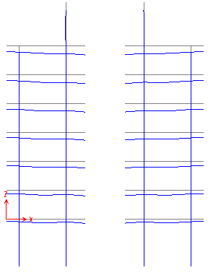
Fig. 6.3 Deflected shape under gravity loading

6.3.1.2 Wind and Earthquake Load

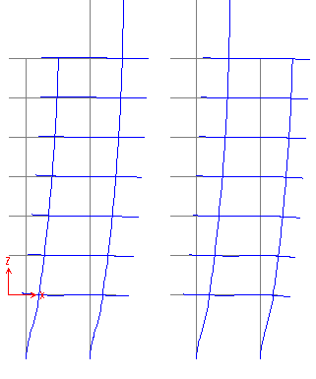
Fig. 6.4 Deflected shape under wind and earthquake loading

6.3.2 Axial Force Diagrams
6.3.2.1 Dead Load
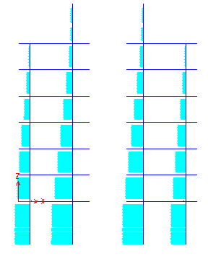
Fig.6.5 Axial Force Diagram for dead load - Scale factor = 0.002

6.3.2.2 Live Load
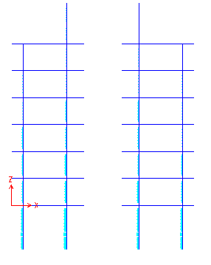
Fig. 6.6 Axial Load Diagram for live load - Scale factor = 0.002
6.3.2.3 Wind Load along +X direction
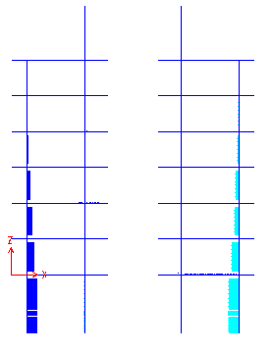
Fig.6.7 Axial Force Diagram for wind load (along +X) - Scale factor = 0.01

6.3.2.4 Wind Load along +Y direction
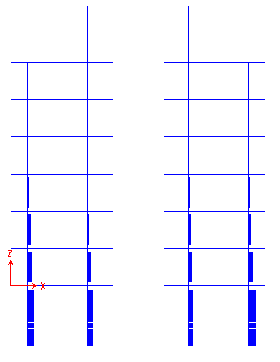
Fig.6.8 Axial Force Diagram under wind load (along +Y) - Scale factor = 0.01
6.3.2.5 Earthquake Load
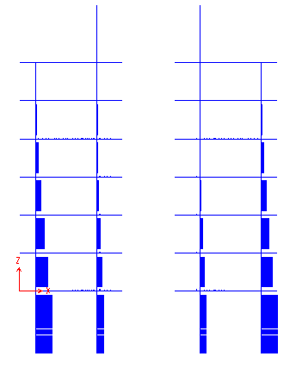
Fig. 6.9 Axial Force Diagram for seismic load - Scale factor = 0.006

6.3.3 Shear Force Diagrams
6.3.3.1 Dead Load
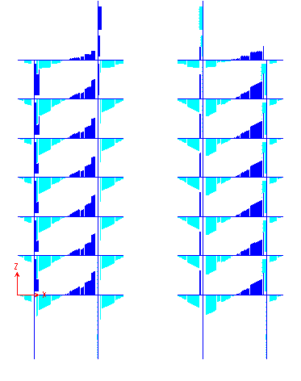
Fig. 6.10 Shear Force Diagram for dead load- Scale factor = 0.03
6.3.3.2 Live Load
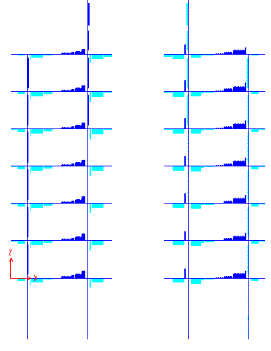
Fig. 6.11 Shear Force Diagram for live load - Scale factor = 0.1

6.3.3.3 Wind Load along +X direction
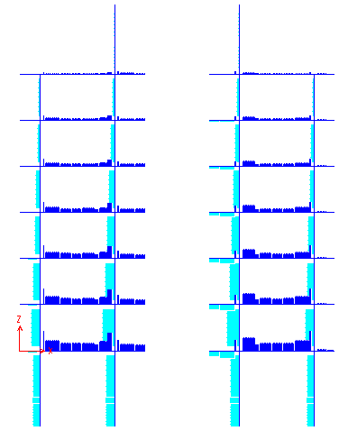
Fig. 6.12 Shear Force Diagram for wind load (along +X) - Scale factor = 0.03
6.3.3.4 Wind Load along +Y direction
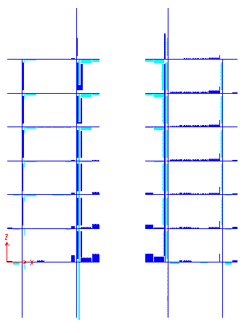
Fig. 6.13 Shear Force Diagram for wind load (along +Y) - Scale factor = 0.5

6.3.3.5 Earthquake Load
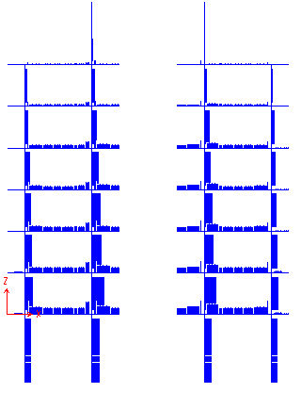
Fig. 6.14 Shear Force Diagram for seismic load - Scale factor = 0.025
6.3.4 Bending Moment Diagrams
6.3.4.1 Dead Load
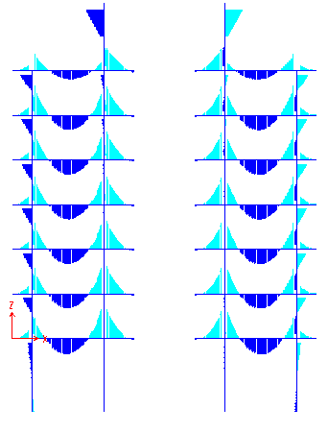
Fig. 6.15 Bending Moment Diagram for dead load - Scale factor = 0.05

6.3.4.2 Live Load
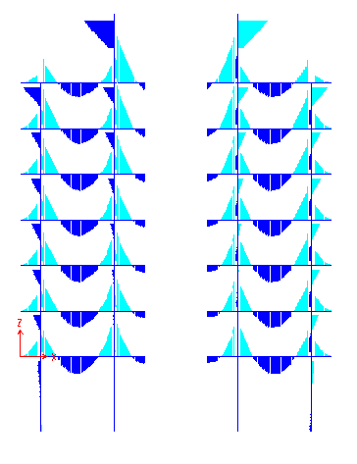
Fig. 6.16 Bending Moment Diagram for live load - Scale factor = 0.5
6.3.4.3 Wind Load along +X direction
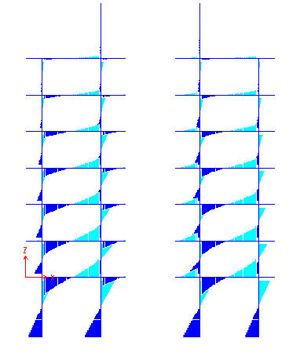
Fig. 6.17 Bending Moment Diagram for wind load (along +X) - Scale factor = 0.03

6.3.4.4 Wind Load along +Y direction
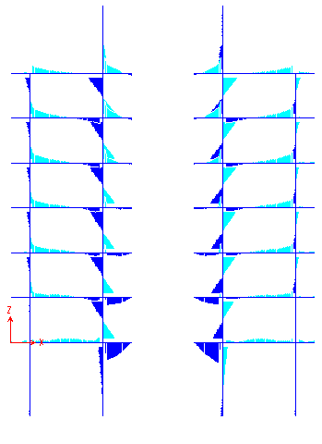
Fig. 6.18 Bending Moment Diagram for wind load (along +Y) - Scale factor = 0.7
6.3.4.5 Earthquake Load
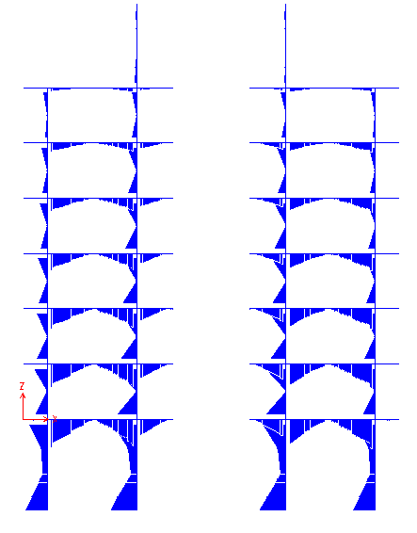
Fig. 6.19 Bending Moment Diagram for seismic load -Scale factor = 0.025

NOTE - 1: Forces and moments diagrams for wind along -X and -Y direction will be mirror image of diagram for wind along +X and +Y direction respectively.
NOTE - 2: Various force and moment diagrams can be compared by normalizing their scale factors.

6.3.5 Discussion
As we can observe, most of the compressive axial load is accounted by gravity loads, specifically dead load. But, wind and earthquake tend to produce tension in some columns. Though, comparatively small in magnitude, this becomes important when soil conditions are such that there is not enough resistance to ‘pullout’ of the column. Special precautions - such as providing key, increasing pull-out resistance and providing tension piles - should be taken to prevent such failures.

Shear Force Diagrams of gravity and lateral loads differ by the fact that shear forces produced by gravity loads vary from positive at one end to negative at other but wind and earthquake tend to produce unidirectional shear forces in the member, which is reversible due to change in direction of loading.

It can also be noted that while gravity load cause maximum positive moment at mid-span seismic force results in small moments at mid-span. Negative moments are developed at the beam column junction in both cases

6.4 SUMMARY
Verification of gravity load analysis by SAP using simplified manual method of Substitute Frame analysis validates the modeling and analysis procedures of the SAP package. Forces and moments diagrams under gravity and lateral loads emphasizes following points:
- Lateral load effects are reversible in direction while gravity load effects are not.
- Gravity loads necessarily cause compression in columns, but lateral load may produce tension also.
- Moments in a section are governed by lateral loads - specifically earthquake loads but gravity loads govern axial force and shear design.

