5. RESPONSE SPECTRUM ANALYSIS

5.1 GENERAL
Response Spectrum Analysis of the buildings can be performed using SAP2000 one of the two ways:
- Defining all frame elements for only stiffness without mass and lumping all floor mass at the center of each floor, which is the point of application of resultant axial forces of all columns at that floor level obtained from gravity load analysis.
- Modifying section / material properties of structural components such as to account for all loads - including imposed dead and live load - without changing stiffness.
The second procedure is adopted for analysing this structure, since it -
  - Eliminates the need of calculating center of mass; and
  - Takes into account the actual spatial distribution of mass.
However, it is found that time periods and forces are exactly same from both methods by running Response Spectrum analysis on trial section.

Response Spectrum function is inputted in form of absolute acceleration, A_{h} multiplied by ‘g’, in m/s² versus time period, T, in seconds. Response Spectrum case ‘EQ’ uses this function for two mutually perpendicular directions U_{x} and U_{y} with equal weights. Square Root of Sum of Squares (SRSS) is used for modal and directional combinations. Thus, effective earthquake force due to earthquake in two perpendicular directions is
EL_{eff} = $\sqrt{{\text{EL}}_{x}^{2}+{\text{EL}}_{y}^{2}}$
As an alternative to the above directional combination, earthquake code also permits the use of following:
EL = maximum of the following three combinations:
± EL_{x} ± 0.3 EL_{y} ± 0.3 EL_{z}
± EL_{y} ± 0.3 EL_{x} ± 0.3 EL_{z}
± EL_{z} ± 0.3 EL_{x} ± 0.3 EL_{y}
The total number of modes considered for analysis is 10, though it is observed that even 3 are enough for giving requisite minimum mass participation of 90%. Eigen Vector type analysis option is chosen.

5.2 MANUAL CALCULATION
5.2.1 Seismic Weight
Seismic weight of the structure includes total dead load plus fraction of live load - 25% for LL ≤ 3.0 kN/m² and 50% for LL > 3.0 kN/m².

5.2.2 Calculation Procedure
The approximate fundamental natural period of vibration of a RC moment resisting frame building without brick infill - since non-structural walls are not considered in analysis - is given by empirical expression specified in the code:
T_{a} = 0.075 × h^{0.75}, where
h = height of the building in m, from support
The design horizontal acceleration spectrum is calculated as,
A_{h} = $\frac{(\frac{z}{2})(\frac{S_{a}}{g})}{(\frac{R}{I})}$
Meanings of these terms are described in chapter 3.
Total design lateral force or design seismic base shear, V_{B} along any principle direction is determined as:
V_{B} = A_{h} × W
where A_{h} is as defined above and W is seismic weight of the whole building.

This base shear is distributed to different storeys based on the parabolic distribution of seismic weight of different floors by following expression,
Q_{i} =$V_{B}$ $\frac{W_{i}h_{i}^{2}}{\sum_{j=1}^{n}{W_{j}h_{j}^{2}}}$; where
Q_{i} = Design lateral force at floor i,
W_{i} = Seismic weight of floor i,
h_{i} = Height of floor i measured from the base, and
n = number of storeys in the building.

5.2.3 Calculation of Lateral Forces
Seismic weight of the building is calculated as follows:

Table 5.1 Seismic weight calculation of the building

Weight (kN) of: | Floor = 0 | Floor = 1-5 | Floor = 6 | Floor = 7 | Floor 8
Beams | 787 | 787 | 787 | 201 | 227
Columns | 700 | 528 | 343 | 142 | 105
Walls | 4604 | 4604 | 2356 | 495 | 441
Slabs | 2077 | 2077 | 2077 | 585 | 443
Imposed DL | 933 | 933 | 1166 | 218 | 209
Imposed LL | 1166 | 1166 | 700 | 816 | 125
Total seismic wt: | 9392 | 9221 | 6903 | 1845 | 1456
Time period of oscillation, T_{a} = 0.075 × (25.85)^{0.75} = 0.86 s
Corresponding $\frac{S_{a}}{g}$ = 1.163, for rock
Hence, A_{h} = $\left(\frac{0\text{.}\text{24}}{2}\right)\left(\frac{1\text{.}0}{5\text{.}0}\right)1\text{.}\text{163}$ = 0.028
So base shear is 2.8% of total seismic weight = 0.028 × 65700 = 1840 kN
Next table will present lateral load distribution across different storeys.

Table 5.2 Lumped mass and storey shear
Floor | Seismic Wt. (kN) | h_{i} (m) | W_{i}h_{i}² (10³) | $$\frac{W_{i}h_{i}^{2}}{\sum_{i=1}^{8}{W_{i}h_{i}^{2}}}$$ | Q_{i} (kN)
0 | 9392 | 4.95 | 230 | 0.0150 | 27.6
1 | 9221 | 7.95 | 583 | 0.0379 | 69.7
2 | 9221 | 10.95 | 1106 | 0.0718 | 132.1
3 | 9221 | 13.95 | 1794 | 0.1165 | 214.4
4 | 9221 | 16.95 | 2649 | 0.1720 | 316.5
5 | 9221 | 19.95 | 3670 | 0.2383 | 438.5
6 | 6903 | 21.95 | 3326 | 0.2160 | 397.4
7 | 1845 | 24.05 | 1067 | 0.0693 | 127.5
8 | 1456 | 25.85 | 973 | 0.0632 | 116.3
Total | 65700 |  | 15398 | 1.000 | 1840.0

5.3 RESPONSE SPECTRUM ANALYSIS RESLUTS: SAP2000
Output of Response Spectrum Analysis by SAP2000 is presented below:
Total seismic mass of the building = 6657.541 tonnes = 65310.47 kN ≈ 65700 kN Mode periods and mass participation is tabulated as follows,

Table 5.3 Mode periods and mass participation
Mode | Period (s) | U_{x} (%) | Cum. U_{x} (%) | U_{y} (%) | Cum. U_{y} (%) | U_{z} (%) | Cum. U_{z} (%)
1 | 1.8982 | 0.00 | 0.00 | 94.42 | 94.42 | 0.00 | 0.00
2 | 1.6006 | 45.83 | 45.83 | 0.00 | 94.42 | 0.00 | 0.00
3 | 1.4988 | 46.48 | 92.32 | 0.00 | 94.42 | 0.00 | 0.00
4 | 0.5788 | 0.00 | 92.32 | 4.29 | 98.71 | 0.00 | 0.00
5 | 0.4925 | 3.17 | 95.48 | 0.00 | 98.71 | 0.00 | 0.00
6 | 0.4762 | 2.73 | 98.21 | 0.00 | 98.71 | 0.00 | 0.00
7 | 0.3212 | 0.00 | 98.21 | 0.62 | 99.33 | 0.00 | 0.00
8† | 0.2521 | 1.23 | 99.44 | 0.00 | 99.33 | 0.00 | 0.00
9† | 0.2080 | 0.00 | 99.44 | 0.30 | 99.63 | 0.00 | 0.00
10† | 0.1401 | 0.00 | 99.44 | 0.00 | 99.63 | 90.64 | 90.64
† Residual mass modes
Base Reactions, combined for all modes and all directions of spectral accelerations,
V_{Bx} = 1674.946 kN M_{Bx} = 20886.134 kNm
V_{By} = 1966.117 kN M_{By} = 18324.490 kNm
V_{Bz} = 3.814 kN M_{Bz} = 36922.457 kNm
Since earthquake code requires that all forces and moments be scaled up if base shear calculated from Response Spectrum (V_{B}) is less than that obtained from approximate fundamental time period (V_{B}^{T}), these will be scaled by a factor equal to
$\frac{V_{B}^{T}}{V_{B}}$ = $\frac{\text{1840}}{\text{1675}}$ = 1.1
5.4 MODE SHAPES
As observed form the SAP output, only 3 mode shapes are sufficient to account for 90% of modal mass participation in both X and Y directions, for which SRSS combination is carried out. But, 10th mode accounts for about 91% of modal mass in Z direction too. A brief description of each mode shape is given below:

MODE 1 | Accounts for 95% of mass in Y direction in form of half-sine curve
MODE 2 | Accounts for 46% of mass in X direction in form of half-sine curve, also torsion mode with center of rotation at location of column C9
MODE 3 | Accounts for 46% of mass in X direction in form of half-sine curve, also torsion mode with center of rotation at location of column C27
MODE 4 | In Y direction in form of two half-sine curves
MODE 5 | In X direction in form of two half-sine curves, also torsion mode with center of rotation at location of column C9
MODE 6 | In X direction in form of two half-sine curves, also torsion mode with center of rotation at location of column C27
MODE 7 | In Y direction in form of three half-sine curves
MODE 8 | In X direction in form of three half-sine curves, Small torsion also, center of rotation outside the plan towards C9 (towards +Y direction)
MODE 9 | In Y direction in form of four half-sine curves
MODE 10 | In Z direction, vertically upwards and accounting for 91% of mass participation

Figures 5.1, 5.2 and 5.3 show the first three mode shapes.
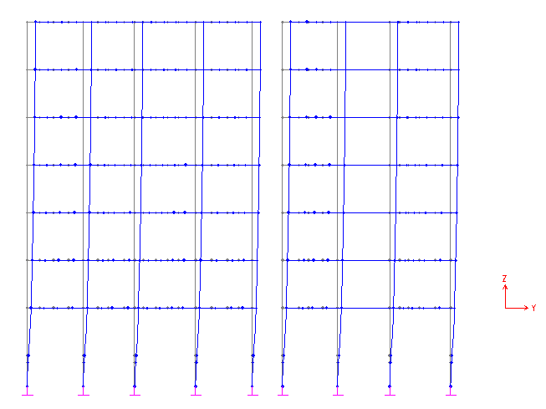
Fig. 5.1 First mode shape - in Y direction
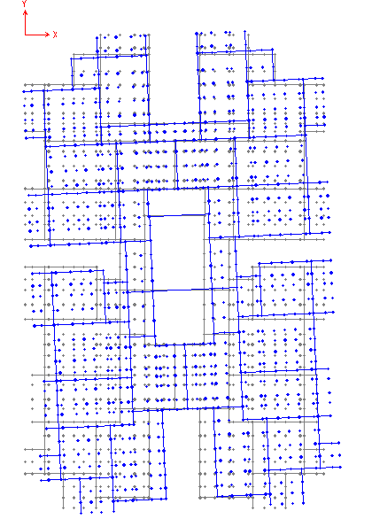
Fig. 5.2 Second mode shape - in X direction

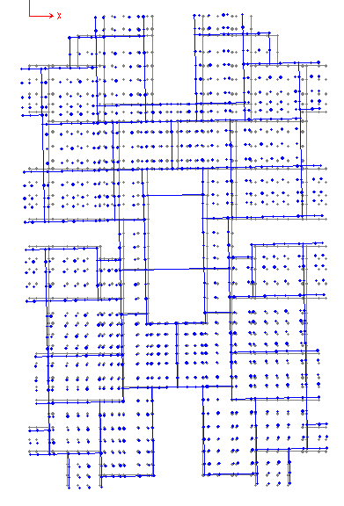
Fig. 5.3 Third mode shape - in X direction

5.5 SUMMARY
This chapter explains steps for calculating lateral forces at each storey height using approximate time period obtained from the code. Results of manual analysis are compared with those of SAP and found to be in satisfactory agreement. Base shear from SAP analysis is 1675 kN while manual calculation gives 1840 kN, i.e. only10% more. Total seismic weight of the building as manually calculated matches excellently with that from SAP analysis, but fundamental time period differ by a factor of more than 2.

Interestingly, it is observed that first mode time period of SAP analysis agrees reasonably with that obtained from the code if degrees of freedom are restricted in two directions. This indicates that time period from approximate formula of code corresponds to degree of freedom in only one direction. This is further justified by the fact that the code provides two fundamental time periods for earthquake in two different directions (for RC frame with brick infill).

Chapter is concluded by summarising characteristics of various modes along with their figures.

