4. STRUCTURE MODELING

4.1 GENERAL
This chapter deals completely with the modeling aspects of the building using FEM based software SAP2000 (Structural Analysis Program). Various facilities available in SAP are discussed along with process of modeling structural component and materials. Calculations pertaining to wind load calculation are presented. Dead Load and Live Load used for gravity load analysis are also mentioned. Figures of model are included at the end of this chapter.

4.2 MODELING
Since this is normal moment resisting frame structure, main components to be modeled are:
- Beams and Columns
- Slabs
- Foundation
- Water tanks and Staircases
- Walls
No plinth beams or parapet wall is modeled.

4.2.1 Beams and Columns
Beams and Columns are modeled as frame elements in SAP. Each element is connected to other frame elements by moment resisting joints. Since design forces and moments are important at faces of columns only, ‘End Offsets’ are provided at both ends of each frame element. This is required because these elements are modeled as line elements but actually they have finite size. Stiffness of beam section is practically infinite from center to center intersection point with column to the face of the column section, but SAP – without End Offset command – assumes same as stiffness there same as at any other section. End Offsets eliminate this by ensuring that two ends of frames are rigidly connected at beam column junction.
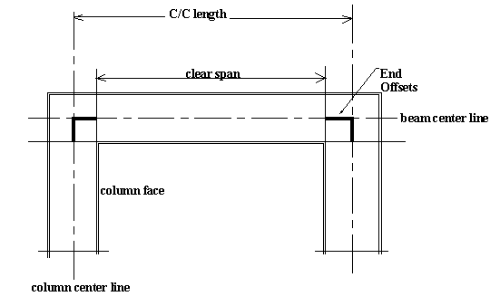
Fig. 4.1 Use of End-Offsets at Beam-Column Junction

4.2.2 Slabs
Slabs are modeled as shell element whose bending and torsion thickness are same and equal to slab thickness. Since stresses in slabs are not significantly affected by lateral loads, they are designed for gravity load combination only. Thus purpose of modeling slabs here is not to determine design forces but to:
- Uniformly distribute DL and LL. This is expected to more accurate then triangular or trapezoidal distribution of loads on beams based on 45⁰ dispersion.
- Contribute to seismic weight of the floor thus eliminating the need to lump masses at each floor.

4.2.3 Foundation
In the absence of any geotechnical information, it is assumed that building is supported on rock. Thus foundation is modeled as fixed at the top of the raft foundation at a depth of 1.5m below ground level and 1.95m below ground floor level.

4.2.4 Water Tanks and Staircases
Load of the water tank is taken as uniformly distributed load on the slab of tank floor. Also this mass is lumped with floor mass for seismic analysis. Similarly load on and due to staircases is also considered UDL.

4.2.5 Walls
Non-structural brick infill walls do not play any contribution in load resistance under vertical loads but tend to act like inclined strut under lateral loads due to distortion in shape of frame section. However, brick infill is not modeled as inclined strut in this analysis and only self-weight of wall is distributed as UDL on beams.

4.3 MATERIAL
For the purpose of analysis following material properties are assumed for concrete:
Grade of Concrete = M25
Grade of Steel = Fe415
Unit weight = 25 kN/m³
Unit mass = 2.55 tonnes/m³
Young’s Modulus of Elasticity = 5000$\sqrt{f_{\text{ck}}}$= 25 × 10⁶ kN/m²
Poisson’s Ratio = 0.15

For Response Spectrum analysis of the structure, seismic weight of each floor has to be lumped to the floor center of mass. This can be avoided if each element is given its self weight which will be automatically accounted by SAP. But SAP does not take care of the external LL and DL though they contribute to the seismic weight. This can be resolved in either of the two ways:
- Lumping additional mass at center of mass of floors
- Increasing self weight to account for this mass – this can be done without increasing section dimensions and hence stiffness, by increasing material density. Thus material properties become function of element dimension and imposed unaccounted load.
For example, modified unit weight of slab concrete = 25.0 + $\frac{\text{externalUDL}}{{\text{slab}}_{\text{thickness}}}$
And modified unit weight of beam concrete = 25.0 + $\frac{\text{externalUDL}}{\text{bD}}$

4.4 SECTIONS
4.4.1 Beam and Column Sections
Frame sections can be defined by selecting the shape, material, dimensions and reinforcement details. All common shapes are available while standard sizes of steel sections are also enlisted. It has been found that results of analysis are independent of frame element reinforcement. Thus default reinforcement is accepted for analysis in this case.

4.4.2 Slab Sections
Shell sections can be defined by selecting material and thickness. Options of modeling element as shell or plate are available.

4.5 LOADING
Different load cases are defined as follows:
4.5.1 Dead Load
Apart from the self weight, following imposed dead loads are considered in the analysis:
‘Finishing’ on terrace = 1.5 kN/m²
‘Partition wall’ on terrace = 1.0 kN/m²
‘Finishing’ on inner apartment floor = 1.0 kN/m²
‘Partition wall’ on inner apartment floor = 1.0 kN/m²

4.5.2 Live Load
Following imposed live loads are considered in analysis:
LL on accessible terrace = 1.5 kN/m²
LL due to 1.2m water height = 11.77 kN/m²
LL on living room, bedroom, kitchen floors = 2.0 kN/m²
LL on balconies, verandas = 3.0 kN/m²

4.5.3 Wind Loads
4.5.3.1 Calculation Procedure:
Wind loads are equivalent static load representative of the pressure induced by wind on the structure. According to IS 875(Part III):1987, India is divided into 6 wind zones of basic wind speeds (V_{b}) 33, 39, 44, 47, 50, 55 m/s. For cyclonic regions, this speed is to be increased by 15%.

Design wind speed at height z is given by,
V_{z} (m/s) = V_{b} × k₁ × k₂ × k₃, where
k₁ = probability factor / risk coefficient – function of mean probable design life of structure and basic wind speed
k₂ = terrain, height and structure size factor – function of terrain category (based on obstruction to wind), building size (based on greatest horizontal or vertical dimension) and height from ground level
k₃ = topography factor – function of upwind ground slope

Design wind pressure at height z is given by,
P_{z} (N/m²) = 0.6 V_{z}²
Wind load on the exposed area can be calculated as,
F = C_{f} A_{o} P_{z,} where
C_{f} = Force coefficient – function of dimensions of the building
A_{o} = Exposed area over which wind is acting
Thus this load is applied on the building and static elastic analysis is carried out using SAP2000.

4.5.3.2 Wind Load Calculations:
Basic wind speed, V_{b} = 50 × 1.15 = 57.5 m/s (due to cyclonic effect)
k₁ = 1.0 for general buildings of mean design life of 50 years for all V_{b}
k₃ = 1.0 for flat ground surface
Since maximum dimension (32m) is between 20.0m to 50.0m, it is Class B building.
Considering Terrain Category 3, wind pressure at various heights can be obtained as presented in Table 4.1
Table 4.1 Design wind pressure

Z (m) | k₂,_{lower} | k_{2,higher} | k₂ (max) | V_{z} (m/s) | P_{z} (kN/m²)
0.00-10.00 | 0.88 | 0.88 | 0.88 | 50.60 | 1.54
10.00-19.95 | 0.88 | 0.98 | 0.98 | 56.35 | 1.91
19.95-25.95 | 0.98 | 1.01 | 1.01 | 58.08 | 2.02
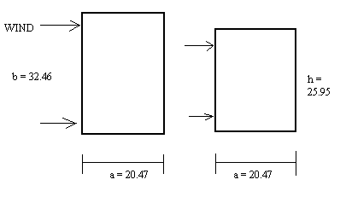
Fig. 4.2 Wind Load Calculation
When wind is normal to longer side,
a / b = 20.47 / 32.46 = 0.638
h / b = 25.95 / 32.46 = 0.800
from Chart provided in IS 875(Part III):1987, C_{f} = 1.2
When wind is normal to shorter side,
a / b = 32.46 / 20.47 = 1.586
h / b = 25.95 / 20.47 = 1.268
so, C_{f} = 1.08
UDL due to wind on a floor,
= 1.20 P_{z} × half of sum of floor to floor heights above and below (normal to longer side in plan)
= 1.08 P_{z} × half of sum of floor to floor heights above and below (normal to shorter side in plan)

4.5.4 Earthquake Loads
For zone IV, following values of parameters is used in defining Response Spectrum,
Zone factor, Z = 0.24
Response Reduction Factor, R = 5.0 for ductile detailing following provisions of IS 1392:1993.
Response Spectrum function is inputted as A_{h}×9.81 vs. T for T ranging from 0.00 to 4.00. Complete Response Spectrum function is tabulated in Appendix-A. Response Spectrum case ‘EQ’ is defined with above function and unity multiplier for U_{x} and U_{y} and zero for U_{z}. Total numbers of modes, including residual mass modes, are ten. Modal combination as well as directional combination is achieved by SRSS rule.

4.6 LOAD COMBINATIONS
Following load combinations are considered to evaluate worst case design loads as prescribed by IS 456:2000 and IS 1893:2002.
COMB1 = 1.5 (DL + LL)
COMB2 = 1.2 (DL + LL + EQ)
COMB3 = 1.2 (DL + LL - EQ)
COMB4 = 1.2 (DL + LL + WIND)
COMB5 = 1.2 (DL + LL - WIND)
COMB6 = 1.5 (DL + EQ)
COMB7 = 1.5 (DL - EQ)
COMB8 = 1.5 (DL + WIND)
COMB9 = 1.5 (DL - WIND)
COMB10 = 0.9 DL + 1.5 EQ
COMB11 = 0.9 DL - 1.5 EQ
COMB12 = 0.9 DL + 1.5 WIND
COMB13 = 0.9 DL - 1.5 WIND
Design will be based on maximum of all these.

4.7 MODEL FIGURES
4.7.1 Building Models
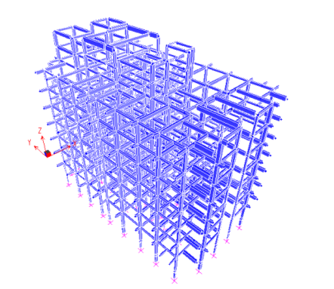
Fig. 4.3 Three-Dimensional view of the model – Perspective View

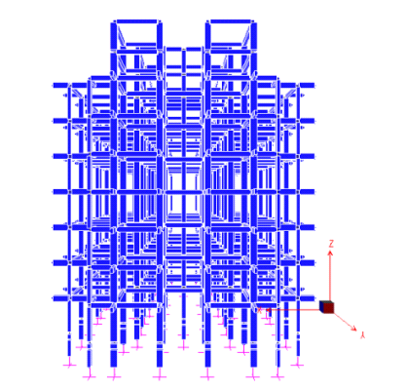
Fig. 4.4 Three-Dimensional view of the model – along (-) Y axis

4.7.2 Plan of the Building
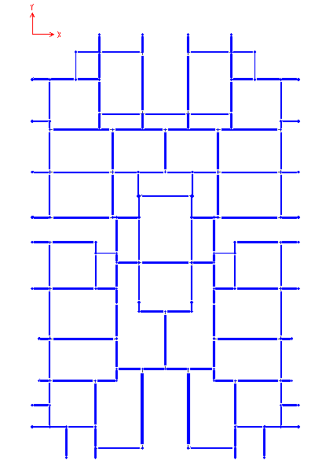

Fig. 4.5 Plan of the building

4.7.3 Frame Sections

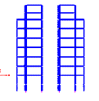  XZ Plane @ Y = -1.34 | 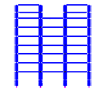  XZ Plane @ Y = -6.1
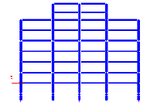  XZ Plane @ Y = -7.28 | 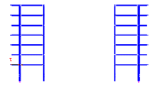  XZ Plane @ Y = -10.56
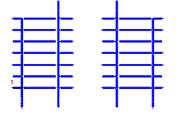  XZ Plane @ Y = -14.03 | 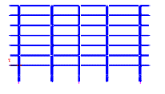  XZ Plane @ Y = -15.93
Fig. 4.6 Frame section in XZ plane
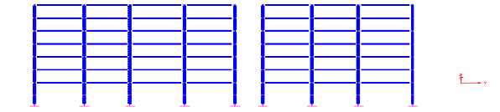
Fig. 4.7 Frame Section in YZ Plane @ X = 1.34 & 19.13

4.8 SUMMARY
In this chapter, all aspects related to modeling of this building in SAP2000 packages are discussed. Modeling considerations of various structural components like beam, column, slab, wall, foundation etc. are presented. Material properties used for analysis are also enlisted along with method for necessary change in material density to take into account external loads into earthquake load analysis. Beam, Column and slab section are defined for appropriate material properties and structural action. Calculation for estimating equivalent static wind load is shown along with dead and live load values used for corresponding analysis. Chapter is concluded with specifying load combination for design and presenting figures of SAP model of the building.

