3. ANALYSIS PROCEDURES

3.1 GENERAL
One of the main factors governing the economy and the safety of structural design is the accuracy of analysis. The fact that design is nothing but assuming section properties and then checking (analysing) for adequacy proves that the better and more reliable the result of analysis are, the safer and economical the design would be.

Over the years, many methods of analysis have evolved, but ‘better’ results require more efforts too. After the advent of computers, various analysis software are available which can do faster and more calculation thus improving accuracy of analysis. But few simple methods of analysis are still popular amongst practicing engineers because they are fast, can give rough idea beforehand and serves as tool to check validity of software output. This chapter will cover some procedures used in analysis of this building with special reference to Response Spectrum Method.

3.2 GRAVITY LOAD ANALYSIS
The gravity load analysis is linear static analysis of structure under vertical loads, acting on it due to gravity. This includes analysis under Dead Load (DL) – self weight of structural elements as per IS 875(Part I):1987 and Imposed Load (IL) – external DL and Live Load (LL) as per IS 875(Part II):1987. This analysis ensures that the structure is able to sustain normal gravity loads in compliance with IS 456:2000. No earthquake or other lateral loads are considered. Gravity load analysis is also used as one of the load combinations to calculate design forces on structural elements. Software package SAP2000 performs gravity load analysis using Finite Element Method.

A simple but approximate method of gravity load analysis is the Substitute Frame Method which is based on Moment Distribution Method and ideally suited for analysing non-sway frames. This involves analysing ‘substitute frames’ (partial frames) by Moment Distribution Method and is based on the justification that resultant forces (and moments) at any section are not significantly influenced by gravity loads on spans far removed from section under consideration. Hence, this method can be used to roughly estimate forces (and moments) for frames which are symmetrical in geometry and loading i.e. without significant sway.

Substitute Frame Method is used for verification of SAP output for DL analysis and comparison is presented in Chapter 6.

3.3 WIND LOAD ANALYSIS
Though wind load is unpredictable and dynamic in nature, IS 875(Part III):1987 prescribes linear static analysis under calculated lateral loads. The loads are estimated based on pressure exerted by basic wind speed modified for local effects like terrain and topographic conditions, and are functions of geometry of the building. Since wind loads can be reversible, structural element should be able to sustain the forces in either direction. As it is highly improbable that the severe wind is also accompanied by the earthquake, Indian Standard codes, IS 456:2000 and IS 1893(Part I):2002 permit use of wind or earthquake, one at a time, but not both, in load combinations.

3.4 RESPONSE SPECTRUM ANALYSIS
The Response Spectrum Analysis is a linear dynamic analysis which gives forces and moments in structural elements based on Response Spectrum which indeed is a function of earthquake zone of the structure and site conditions. Response Spectrum is a curve representing maximum response of the structure – idealized as single degree of freedom (SDOF) system – with respect to time period. According to IS 1893(Part I):2002 dynamic analysis of building is required if it is

(1) Regular and more than
- 40 m high in zone IV & V or
- 90 m in zone II & III.
(2) Irregular and more than
- 12 m high in zone IV & V or
- 40 m high in zone II & III.

Since this building falls under criteria 2(a), Response Spectrum Analysis is carried out using SAP2000.

IS 1893(Part I):2002 gives Response Spectrum function as follows:
A_{h} =$\frac{\text{ZI}}{2R}$$\left(\frac{S_{a}}{g}\right)$; where
A_{h} = Design horizontal seismic coefficient
Z = Zone factor
I = Importance factor
R = Response reduction factor
$\frac{S_{a}}{g}$ = Average response acceleration coefficient, function of time period T
For rocky or hard soils,
$\frac{S_{a}}{g}$ = 1 + 15T, for 0.00T0.10
= 2.50, for 0.10T0.40
= $1\text{.}\text{00}T$, for 0.40T4.00
Spectral Acceleration vs. Time period curve from IS 1893 (Part I):2002 is reproduced below:
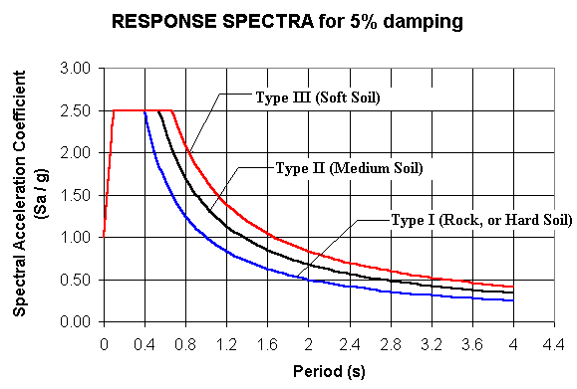
Fig.3.1 Response Spectrum Function as defined by the code

Response Spectrum Analysis of a structure gives different possible mode shapes and corresponding natural periods. These modes can be combined using Absolute combination, Complete Quadratic Combination (CQC) or Square Root of Sum of Squares (SRSS). Code specifies that number of modes to be considered such as cumulative percentage mass participation exceed 90%.
3.5 SUMMARY
In this chapter gravity load analysis, wind load analysis and Response Spectrum analysis are briefly described. Suitability of Substitute Frame Method for checking validity of software output is also explained.

