APPENDIX C
REINFORCEMENT DETAILING DIAGRAMS

C.1 COLUMN
For each column group, two cross-sectional reinforcement detailing diagrams are shown corresponding to the floor numbers (F = 0, 1, 2 etc.) for which the diagram is applicable. With reference to the following figures, it should be noted that
- All dimensions are in mm.
- Figures are not drawn to the scale.
- Stirrup steel spacing indicated as “ 8Y@125 or 75c/c” implies that spacing is 125 mm c/c along the column length except for a distance of 500 mm (for all columns) from the face of the connecting beam towards mid-span of column (both sides) and portion of column connected to the beam. In clarification of this point, reference can be made to Fig. 8.3 (a).
- First bar is placed at 50 mm center from edge of the column.
- All hoops should form a complete loop closed by bending stirrup steel at an angle of 135º and extension should be not less than 160 mm, as shown below:

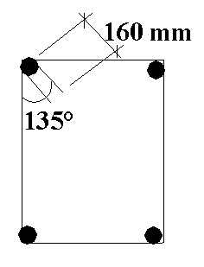
Fig. C.1 Hoop steel detail

